Amended HRAC Minutes
Monday, March 11, 2024
Gatehouse Administrative Building Room #5055
5:45 p.m. to 7:30 p.m.

HRAC Charge: HRAC will make recommendations to improve practices used by FCPS leadership at school and district levels from the lens of professional/business acumen, data integrity, diversity and inclusion to improve FCPS’s national and international competitive standing as it relates to compensation.

HRAC Norms: Punctual*Prepared*Participatory*Positive*Productive*Present*Speak Up

Committee Members | Represents
Dr. Sherry Agnew Scott | Asst. Superintendent for Human Resources
Mr. llryong Moon | School Board Liaison
Anita Guyther-Branch | At Large Representative- Mr. Moon
Leonard Bumbaca | Mason District
Mimi Dash | Providence District
Laverne Henson | At Large Representative
Janet O’Lare | At Large Representative -Rachna Sizemore Heizer
Dionne McGlothin | Sully District
Haile Russom | Franconia District
Stephanie Paduano | Hunter District
Lawerence Webb | Springfield District
Visitors | Represents
Chris Lewis | School Board Aide to Mr. Moon
Krista Simkins | HR Director, Office of Talent Acquisition
Sandra Hardeman | HR Office of Executive Director
Lydia Martinez | HR Director, Office of Labor Relations
Franklin Jones | HR Director, Office of Employee Relations
Maike Dunlap | HR Director, Office Employee Services & Operations
Emily VanDerhoff | Fairfax Federation of Teachers

Laverne Henson, Co-Chair called HRAC meeting to order at 5:45pm

February 22, 2024 meeting minutes and March 11, 2024 agenda were approved for posting.
Dr. Agnew Scott provided an overview for services that have been executed since February 2024 or will be completed by the month of March 2024.
Office of Executive Director (OED)
Key initiatives:
      - Held meeting with business partners to discuss grants
- Enhanced outreach programs
  - One stop shopping management guide for employees available with frequent digital update capability.
  - Developed an invitation to reapply for former FCPS employees from 2019-2024.
  - Established employee conference contact/networking recruitment list.
  - Using out-front media advertisement for operational positions on DMV Metro buses.
  - Collaboration with internal and external offices for cross over processes and procedures.
  - Using Circa for diversity reporting:
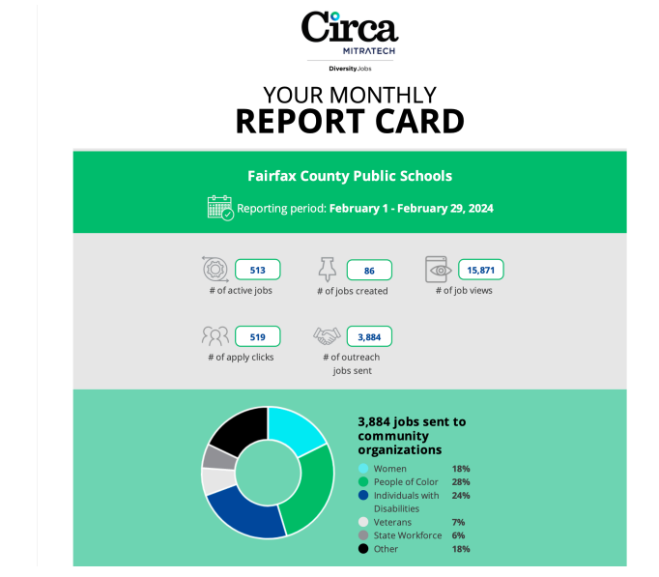
Office of Talent Acquisition (OTA)
Reporting of in-person and upcoming virtual job fairs hosted by HR:
February 24, 2024 in person job fair at Lake Braddock Secondary School outcome
- 521 Registrants
- 175 School Attendees
- 361 Attendees Total
- 301 Attendees from Registrants
- 60 Walk-ins
- 156 Offers Extended
- 80 Offers Accepted
March 14, 2024 virtual job fair using the Brazen platform expected:
- 60 school participates
- 225 registrants

Office of Labor Relations (OLR)
- Employees are concerned that intimidation by principals and program managers are at risk, if policy and guidance is not readily available for the collective bargaining process. Mass mailing is prohibited, but guidelines can be found on the public pages to assist during the feedback loop for employees. Noted that circling back to impacted employee by HR is imperative should it bucket in guardian. This will capture inquires by staff and reach out to administrative based/prompted by union rep concerns.
- To facilitate the future increase workload; another specialist is expected by the election period to assist with the current 3 bargaining unit allocations and 2 exclusion categories identified to date.
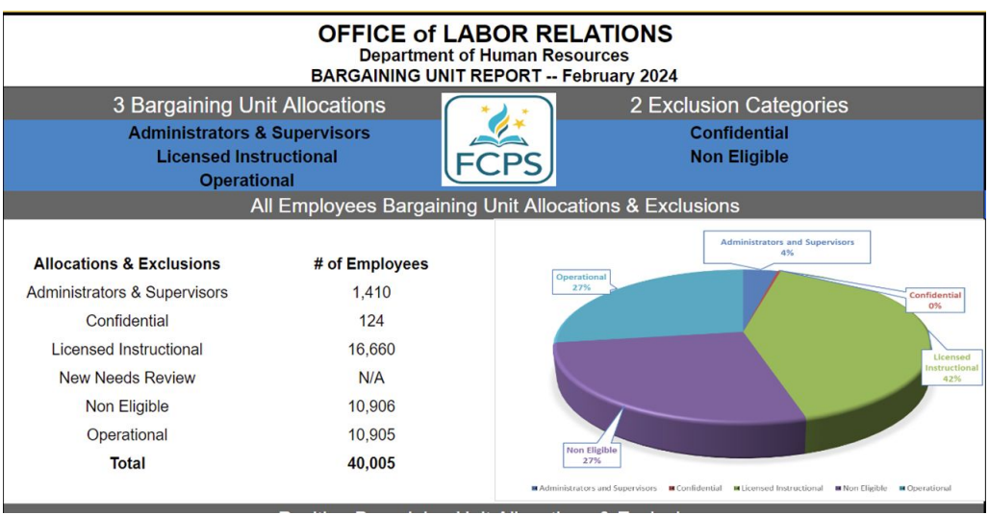

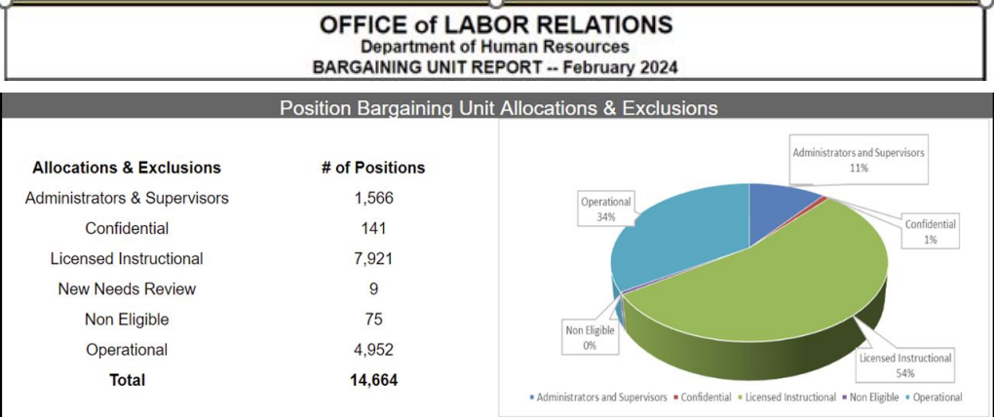

Office of Employee Services & Operations (ESO)
- March 20, 2024 Human Capital Management (HCM) official kick off will focus on the technology modernization program using a three-phase approach within 39-months.
- Client service will conduct remote finger printing in compliance with regulation 4116 due date of December 31, 2024. They expect to complete a total of 30,487 employees finger printing designated for Re-Fingerprinting (7,509) and Re-usable Fingerprints (22,978).
- Classification and Compensation Cyclical Reviews 5-year plan approved in February by Dr. Reid and the School board for 966 regular reviews.
- Update to employees’ salary was adopted under Regulation 4612 for Promotion Procedure at rate of 10% increase from their current salary or a step placement based on their relevant experience, whichever results in a greater salary increase. Additional resources are a part of the drop-down plan.
- Teleworking agreements and alternate arrangements as per Regulation 4417 are under review across the department to assess best business practices for the organization as a whole.
- Expect the New Separation Report delivered to the Board on March 9, 2024.

Office of Employee Relations (OER)
- Employee Relations has 24 persons on board. The goal is to have employees obtain SHRM certification through a paid training and testing initiative
- Investigators will complete a writing class for continuity of services and standardization of reporting.
- To provide a better customer service experience, all telephone calls and emails will be responded to within 24 hours during business days.

Subcommittee Breakout Sessions.
CCA1 Classification and Compensation Advocacy – (Diverse Workforce)
Subcommittee Lead - Janet O'Lare, Rachna Sizemore Heizer At- Large Rep.
Angela Thompson, Mount Vernon District
Dionne McGlothin, Sully District
Amira Bouhsane, Student Representative
Anita Guyther-Branch, lIryong Moon, At Large Rep.

CCS2 Compensation and Competitive Standings – (Data Analytic)
Subcommittee Lead - Haile Russom, Franconia District
Idanishia Cairo, Dransville District
Jeanmarie Nagle, Fairfax Teachers Ass.

EER3 Employee Rights and Responsibilities – (Clogged Processes/Barriers)
Subcommittee Lead - Mimi Dash
Stephanie Paduano - Hunter Mill District
Lawerence Webb, - Springfield

Tasks and Action Items for Subcommittees:
Input requirements - on going
- School Board & District leaders’ priorities
- HR Directors presentations and response to committee questions due Mar 11, 2024
- Meeting minutes from Oct-Feb
- FCPS Strategic Plan
- HRAC Charge
- Goals

Output requirements due April 8, 2024
- 3-6 Objectives
- Request for data

Output requirements due May 6, 2024
- 3. Analysis/Facts/Data/Metrics
- 4. Recommendations & subcommittee priorities

Output requirements due June 1 2024
- 5. Committee approve of presentation
- 6. Committee sign off presentation
- 7. Co-Chair upload presentation to Board Docs Jun 3, 2024
- 8. Co-Chair present report to SB Thursday, Jun 20, 2024

Wrap Up/Call to Motion

Adjourn: 7:50p.m.

HRAC next meeting April 8, 2024, 5:30 -7:30. Gatehouse Administration Center Room 5055

